

**Name: Abdul Rehman**

**Roll No: 19L-1135**

**Section: CS-D1**

**Course: Digital Logic Design Lab**

**Submission: 11-05-2020  
date**

Post Lab #3

**Q   
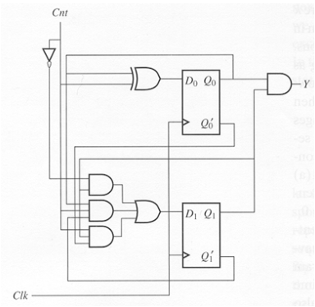  
  
(a)   
Input Equations:**

D0= Cnt⊕Q0  
D1= Cnt'.Q1+Cnt.Q0.Q1'+Cnt.Q0'.Q1

**(b)   
Output Equations:**

**Y= Q0.Q1**

**(c)**

|  |  |  |  |  |  |
| --- | --- | --- | --- | --- | --- |
| Present State | | Input | Next State | | Output |
|
| Q0 | Q1 | Cnt | Q0 | Q1 | Y |
| 0 | 0 | 0 | 0 | 0 | 0 |
| 0 | 0 | 1 | 1 | 0 | 0 |
| 0 | 1 | 0 | 0 | 1 | 0 |
| 0 | 1 | 1 | 1 | 1 | 0 |
| 1 | 0 | 0 | 1 | 0 | 0 |
| 1 | 0 | 1 | 0 | 1 | 0 |
| 1 | 1 | 0 | 1 | 1 | 1 |
| 1 | 1 | 1 | 0 | 0 | 1 |

**(d)  
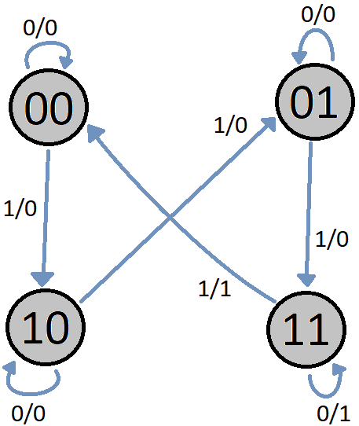**

# THANK YOU 😊

